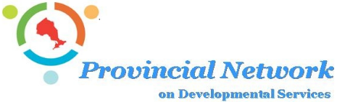
APPROVED
Provincial Network Meeting Minutes
October 19th, 2023
10:00am – 1:00pm via Zoom

PN ATTENDEES

Michelle Brooks (Chair)
Alison McLean (EDI)
Ann Bilodeau (PNHR);
Ann-Marie Binetti (PNHR);
Bob Walsh (OASIS);
Brad Saunders (OASIS/CLO);
Brian Swainson (GLS);
Bryan Keshen (TDSA);
Carolynn Morrison (TDSA);
Chris Brillinger (OPAN);
David Cohen (Faith, Culture & Inclusion);
Eugene Versteeg (CH);
Janet Noel-Annable (CH);
Jo-Anne Demick (CLO);
Kim Thorn (DSO);
Sherri Kroll (PEDG);
Sue Coke (Kerry’s Place/OADD)
Trish Sherwin (Admin Support/Recording Secretary)

PN REGRETS

Brigid Fitzpatrick (Valor Solutions);
Chris Beesley (CLO);
Don Walker (Mary Centre/FCI);
Jason Young (OADD)
Jeanny Scantlebury (CNSC);
Shawn Pegg (CLO);

Guests:
Yona Lunsky

MCCSS ATTENDEES

Karen Glass, ADM, MCCSS
Diane Canzius Moura, Manager, Collaboration and Knowledge Mobilization Unit
Laura Summers
Paulette Thomas, Director, Community and Developmental Services Policy Branch
Ron
Jody Hendry, Director, Developmental and Supportive Services Branch
Nicole Norton, Manager, Direct Service Delivery Unit
Hannah Grzegorczyk; Program Analyst

- Welcome – Michelle Brooks, PN Chair welcomed all to the meeting at 10:06am
- Review and Confirmation of Agenda for October 19th, 2023
Amendments: Moved Golden Horseshoe Letter to item 3a)
The agenda for October 19th, 2023, was approved as amended.
- Review and Confirmation Draft Minutes for September 21st, 2023
Amendments: - Removed “Passport” from page 4 – Bob will review and provide any amendments later if required.
The minutes of the meeting for September 21st, were approved as amended.

2. Business Arising from Previous Meeting
- ACTION: Requesting the PN partners to take the drafted PN Health-DS white paper back to their respective groups to review intensely and provide feedback.
September Update: Deferred to October meeting
October Update: has been shared with local health contacts.
  - The Minister’s office has forwarded it to their policy department.
  - Used a portion of the intro letter when sharing – will share this with the PN Table
  - Suggest to also share the paper by Yona Lunsky
Completed

- ACTION: Trish to attach the white paper to the draft minutes sent out for this meeting (September) next month (October) with any updates forwarded from Bryan Keshen and Brian Swainson and with the water mark removed.
Completed

- ACTION: Michelle will respond back to the MCCSS with names of people from PN able to participate on other tables
October Update: Trish will provide more detail on this action item from previous minutes.
3. New Business
- Golden Horseshoe Letter – Michelle Brooks
  - The PN Stabilization Working group was originally tasked with creating survey questions to gather data.
- Changed focus to creating a letter to MCCSS with follow-up messaging strategy for sector agencies.
- Letter by OASIS and CLO was circulated and then followed-up from Michelle as an Action Item from the last meeting.
- Received a letter from the Golden Horseshoe Executive Directors Group after this circulation, asking for clarity on the purpose of PN and their role in advocacy on behalf of the sector.”
  - Requesting a response to their inquiry by December 7th, and if possible to attend the meeting on this date.
- Michelle has reached out to MCCSS and ADM around this.
- The Golden Horseshoe ED Group was advised by local MPPs to work together with their boards and other agencies and send their message in One Voice
- PN role in advocacy is in bringing together the diversity of voices from around the table to help inform one another and to help identify if there are trending challenges that are large in scope; PN does not create the plans of action or messages for advocacy campaigns
  - There are members at the PN Table that are from advocacy groups.
  - PN helps to facilitates advocacy and sharing of messaging.
- Michelle has reached out to MCCSS-ADM to coordinate a facilitated meeting between she and OASIS/CLO as the advocacy groups at the table.
- The Golden Horseshoe ED Group was advised by local MPPs to work together with their boards and other agencies and send their message in One Voice

- Update from the Stabilization Strategy working group
  - The working group took on the task in August of writing a letter to MCCSS to ask for 5% stabilization funding to our budgets.
  - Looked at the PN Terms of Reference for clarification if the letter should come from PN or other Advocacy groups.
  - OASIS working with CLO and partnering with PN
  - DS Sector needs stabilization funding now.
- Different types of agencies and services in different regions will all have different priorities but our need is very similar -> need stabilizing funding added to our budgets.
- The fact that we are not a homogenous sector will impact the messaging and needs/priorities; will need mor collaboration, coordination and strategy
- Broader Piece:
  - Meeting set with Chief of Staff within 2 weeks.
  - Giving Minister Parsa the chance to help with fixing some of these issues.
- Narrower Piece:
  - SWOT analysis
  - Need for more of a campaign
  - Chronic underfunding
ACTION: Michelle will follow-up with Karen Glass, ADM, to confirm her response that they have what they need from us to move forward with our request for stabilization funding.

- Correspondence
- PN sponsorship of We Inspire Week DSW Video Contest
    - -request for judges
    - -request for message from PN/attend the short forum
    - The video contest will be held the week of November 13-17.
    - Sherri Kroll and Alison McLean both volunteered
    - Table agreed to continue to support the event with the monetary awards for 1st, 2nd, and 3rd, place. ($300/$200/$100)
- Emerging Issues/Questions – All Members
None.
- Topics to discuss with MCCSS – All Members

4. Participant Updates
Current Initiatives/Working Groups:
- DS Workforce Initiative– Ann Bilodeau/Ann-Marie Binetti
  - Well into phase 2 -> Committees working on developing their workplans
  - Will be presenting at the PN HR Forum and look for feedback on the buckets of work.
  - Have moved CCW under the Talent Acquisition and Workforce Development committee workplan
  - The webinar on Organisational Trauma is almost filled.
- Micro Credentials – Michelle Brooks
  - First pilot went through with nurses and allied health professionals (APSEs, BTs and SSWs)
  - In Phase 2 will be looking for instructors; will model to edit programs to be DSW specific; Nano credential as a prerequisite on Health and Health language
- Recruitment and Retention Strategy – Ann Bilodeau
  - Talent Acquisition and Workforce Development Committee has been building the Recruitment and Retention Report-recommendations and findings completed by the consultants into their workplan.
- Regional Planning Table Review – Michelle Brooks
Nothing to report
- Sector Pressures and Strategy working group – Sue Coke
See agenda item 2a)
- CYFSA working group – Bob Walsh
Ongoing – any feedback please bring back to the next PN meeting.
- Strategies to Connect Around Changes to the Fire Code – Michelle Brooks, Bob Walsh and Bryan Keshen
Deferred.

5. Finance/Budget
a) Quarterly Update – Treasurer
- No report

6. Special Guest Presentations
- OPAN presentation; Chris Brillinger
  - What is the future of individualized funding with J2B and how can we use the lessons learned in the Passport Program?
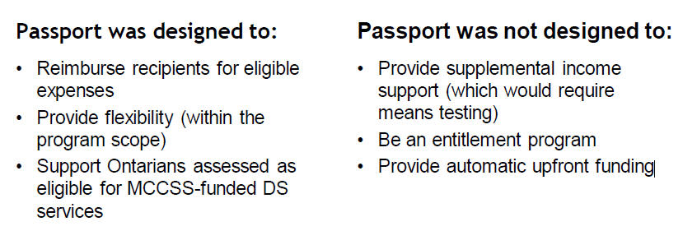

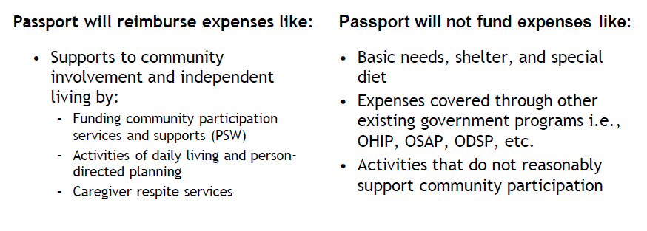
  - Unreconciled advances can have a significant impact on the next year allocations
  - Looking to move to a dashboard way of report data to the regional tables
  - 2 goals:
    - Let’s get TPR-administered recipients to 100% utilization
    - Let’s administer Passport to support the TPR bottom line
  - Suggestion: Try to get standardization of data and where you get it from (ie 100 specific persons year over year.)
  - Helping people integrate their base funding support with their Passport ->
    - through planning and ggoals
    - evaluating effectiveness of the use of these dollars
  - any chance of measuring outcomes and not just utilization and funding as is currently reported on?
    - We would like to get into this or PDP
    - Deepening our conversations with recipients in year one of receiving passport funding
    - Better for them to understand when and how to use it. And how to plan with this.
    - Janet Noel-Annable offered to share the data they have collected
    - Looking at a broad goal of TPAs having 100% utilization rates
      - Look to areas where the utilization rate is high -> find champions to share their processes in accomplishing this.
  - Trend is the higher the allocation the higher the utilization rate is
    - Encourage people to use the resources on the Passport website – how to complete forms, how to use Passport funds etc.
  - Possible capacity to gather data on what they used their Passport dollars for.
  - Performance outcomes and quality of life -> impacts from Passport utilization.
  - Create and facilitate a series of workshops or other training events on knowledge sharing from those organizations that are successful with Passport Utilization.

- Mental Health Surveys – Outcomes; Yona Lansky
  - Yona Lansky provided a presentation on the Mental Health surveys in the Developmental Services Sector during the pandemic recovery – Where are we now and what do we do next?
  - Have been following the health staff since the onset of COVID in 2020
  - In the past 2 years have circulated 4 staff surveys, completed 20 interviews and 2 surveys for leaders.
  - Reviewed the results and challenges as outcomes:
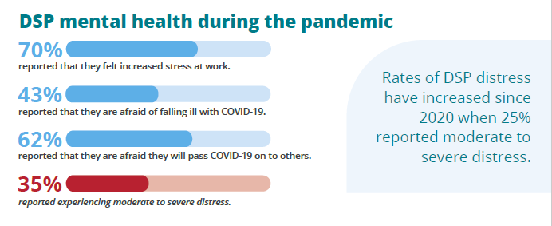
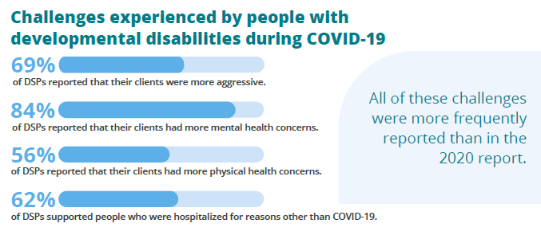
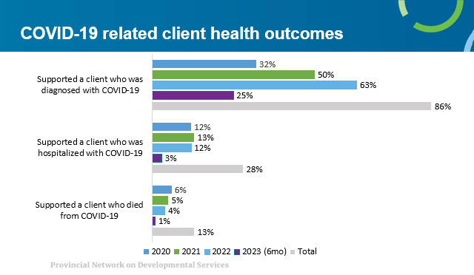

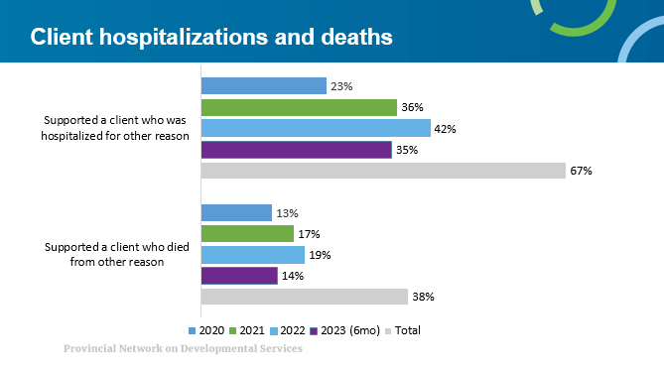

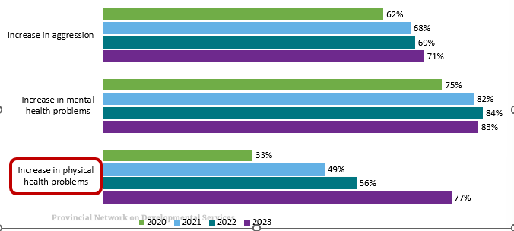

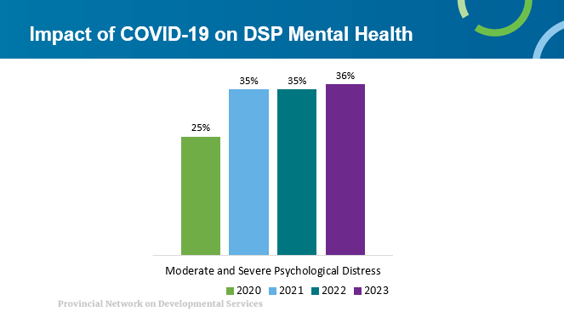

  - Noted that the above number for 2023 is at only 6 months into the current fiscal year.
  - 70% said they sometimes or frequently consider leaving their job in the past year
  - Reasons given why they stay: working relationships is the #1 reason (with supervisors, coworkers and persons supported); Organizational supports such as benefits, pension, pay and professional development opportunities; work context (schedule flexibility, job location, reasonable workloads, positive work culture.); The people they support.
  - Reviewed the stats on grief and loss over the pandemic
  - 44% of DSPs reported barriers to accessing mental health services
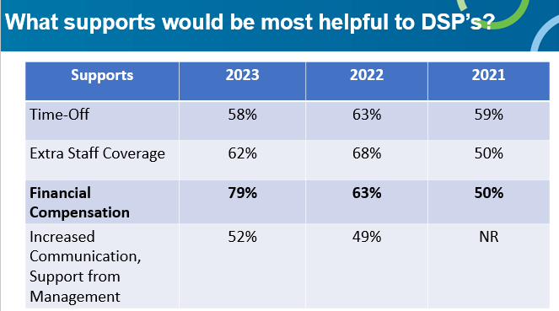

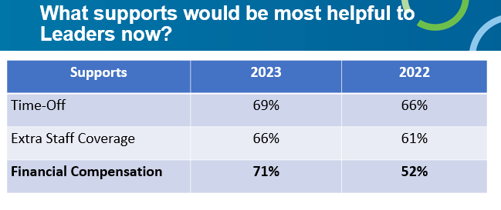
  - CCW - Our Goal is to build a community of practice of people who want to Champion Mental Health in the Workplace in Developmental Services across the province. To reach this goal we have developed a multi-pronged approach with includes:
    - Equipping agency Mental Health and Wellness Committee with tools and resources
    - Facilitating a community of practice for the Champions of Mental Health
    - Educating champions through monthly webinars
    - Training champions through our ECHO-training.
  - Of survey participants:
    - Only 5% of DSPs participated in the CCW initiative (but 71% were interested in participating in future events!). (5% last year)
    - 18% of leaders participated in CCW, primarily in the Mindfulness Program (12% last year)
Importantly there is interest, so now COMMUNICATION AND ACCESSIBILITY of events continues to be critical moving forward.
  - SUMMARY:
    - Client situations seem worse
    - Grief and trauma have accumulated over time
    - Pay looks like it might be a growing concern for DSPs and leaders alike
Discussion
- Q-are there any bright spots even outside of our sector that we could learn from?
A-not something we’ve looked at yet – outside the sector
- Looking for PN comments and feedback on what recommendations to pull from this report.
- If staff are feeling more burnt out than ever this will affect the other areas
  - Is there any metrix for this or is it only their perspective?
- Seeing impact and desire or need for more financial rewards (salaries, wages etc.)
- Turnover in staff could also be an impact and speaks to the need to stabilize.
- Need to increase on our benefits side more Mental Health services and not virtual but in person resources.
- Need an increase to base budgets -> going to see more labour unrest and strikes
- Yona will send an email to Trish to share with the PN table on an upcoming Mental Health workshop/training event.
- Are there any statistics on staff working more than 1 job? Not in the slide deck currently – if so suggest this be added.
- videos on Passport that may be helpful can be found at https://passportfunding.ca/resources

- MCCSS Updates- ADM Karen Glass and Jody Hendry

ADM Updates- October 19, 2023
Passport
- Response from Passport agencies, recipients, and partner agencies, such as brokers and TPRs to the new passport guidelines has been overwhelmingly positive.
- The integration of some expense categories from the temporary expansion of admissible expenditure during Covid-19 outbreak into the new guidelines has provided recipients with continued flexibility for how they can utilize their funding.
- MCCSS has also heard that the rewritten guidelines are more focused on recipients and what they need to know to navigate the program and provide more clarity about types of expenses that are admissible under the program.
- As a result of the updated guidelines, the volume of requests submitted through the extenuating circumstance process is significantly reduced.

Service Agency Working Group
Background- Service Agency (SA) Working Group Profile:

- The Ministry is planning to reestablish a service agency working group comprised of DSCIS users to support the maintenance and implementation activities of the DSCIS application.
- The working group will operate between September 2023 – March 2025 to allow for evaluation of the ability of the ministry to effectively obtain advice and information from service agencies and the ministry’s ability to best incorporate the working group’s feedback and advice.

Service Agency Working Group Membership Selection:
- 23 Agencies were recommended to submit one representative each for membership.
- Regional Offices reviewed and validated the SA membership list.
- TPR Executive Directors were formally invited to participate in the SA Working group.

Dual Diagnosis/ALC
- In 2021/22 the ministry launched the Dual Diagnosis (DD) Alternative Levels of Care (ALC) prototype to transition up to 10 individuals from hospital into community settings. To date, we successfully transitioned 9 DD ALC individuals into the community. In recognizing the complexity of needs of the 10th individual, they are receiving transition support while in the hospital with an expected transition date at the end of this year.

- Building on the success of the pilot, the ministry expanded the DD ALC initiative to transition up to 30 additional individuals from hospital to community settings over 2 years (2023-24 and 2024-25) to make a total of around 40 individuals.
- Planning activities are underway with 8 individuals already transitioned, approximately 14 expected to transition by the end of Q3 (December 2023) and another 6 expected to transition by the end of Q4 2023-24.
- One of the key lessons learned from the DD ALC pilot was the need for training to help service agencies get their teams ready to support DD ALC individuals transitioning to community placements. MCCSS worked with Michelle and the Provincial Network to pilot DS staff attendance and evaluation of a suite of mental health micro credentials training that were developed for the health sector to determine applicability to the DS sector. The micro credentials pilot was a success, and we are increasing our investment to adapt and customize for mental health micro credentials and create a new nano credential designed as a foundational course for DS staff.

Discussion:
- DS becomes a subsection of other areas within the MCCSS and other Ministries – seems to need some structural elements
- Internal & health side -> need for stronger primary health care from data as shown in Yona’s presentation today.
- DS Sector is being kept in mind in planning within MCCSS and MOH to find ways to provide wrap around supports to these individuals
- How can we build the resources to create preventative measure to help decrease the visits to the ER and help build up the resources at the community level?
- 2 pathways identified with MOH and OHTs and integrated care:
  - COPD
  - Heart condition
- Could be ways to integrate the DS health needs with these pathways
- It's a rare hospital that moves beyond a 30-year old view of community based services, and looks at how community care, acute care and primary care need to be seamless from a client perspective. CHCs and FHTs can take more than one issue at a time (And are SDOH framed)... so may be an "in" to the primary care sector.

8. Standing Committees:
- Cultivating Community Wellness – Jeanny Scantlebury
- Remove from agenda going forward.
- OnTrac – Janet Noel-Annable
- Sent a letter based on Ministry’s request on helping to build capacity in readiness for J2B
  - Tried to understand what we were building capacity for
  - Suggested we hire a consultant for this and to work with MCCSS
  - Framework managed and funded
  - No response back from the letter as yet.
  - We did meet with the group through CLO to see if they would work with us on this.
- No questions or concerns from the PN table at this time.
- Potential for engagement -> inviting people to the conversation
- There are a lot of different initiatives around the province
- Mendicant Group report on capacity initiatives developed for autism/Children’s Treatment Centers is completed and now available; does not necessarily scale to DS 22 TPAs vs 300+, but there are elements that can be utilized once we better understand DS needs,
  - Suggest possibly using a different consultant to help prevent any duplication or provide a new perspective.
- PN-HR Committee – Ann Bilodeau
  - Suggest possibly using a different consultant to help prevent any duplication or provide a new perspective.
- Comment: OASIS is working with Sensory Partners to look at transferability of lessons from the "needs based funding" pilot to other parts of the DS sector.

- PN-HR Committee – Ann Bilodeau
- Friday October 20th -> conversation with colleges scheduled.
- Provincial Network Health Working Group- Bryan Keshen & Brian Swainson
- No additional report.
- QAM- Sherri Kroll/Janet Noel-Annable
- Letter meets the RCMP requirement; how do we go about circulating this?
ACTION: Trish will share the final letter for vulnerable sector checks with the PN Table and the Regional Planning Tables under separate cover and emails.
- Participant Updates
  - CLO – Chris Beesley/Jo-Anne Demick
- Requesting agenda time at the next PN meeting on Individualized funding.

  - CNSC – Jeanny Scantlebury
- No report.

  - DSO – Kim Thorn
- No report.
  - EDI-Community of Practice – Alison McLean
- No report.
  - FCI (Faith, Culture & Inclusion) – Don Walker
- No report.
  - GLS – Brian Swainson
- Concerns around changes to ACV certification coming up July 2024. Created a working group to request clarification
  - OBRC and OASIS had completed a report on Individualized funding.
  - OADD – Sue Coke
- No report.
  - OASIS – Bob Walsh/Dave Ferguson
- No report
  - OPAN – Chris Brillinger
- No report.
  - PEDDC – Sherri Kroll
    - No report.

- Closing Comments and Adjournment
- Adjourned at: 1:10pm
- Next PN ‘Meeting’ the 3rd Thursday of each month for 2023
Thursday November 16th, 10am – 1pm virtual via zoo
Item 8b – OnTrac Letter

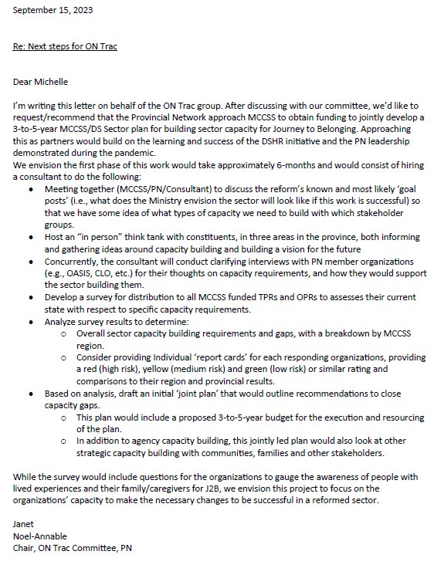

Item 6 – MCCSS Update provided by MCCSS

ADM Updates- September 21, 2023

Acknowledging Agency Constraints
- The ministry acknowledges the challenges agencies are facing as a result of the current economic environment including inflationary pressures and increasing wages; driven in part by collective agreements in other sectors.
- The ministry encourages agencies to continue to share specific details and data with your ministry contact. This may include vacancy rates, the amount of staff overtime needed, and the impacts to services. These details will help us document and understand the impacts.

Workforce
- Four sector led task groups under the Developmental Services Workforce Initiatives Steering Committee (DSWIC)- Skills Development and Training, Talent Acquisition and Workforce Development, Research Data and Indicators, and Communications, were launched and started meeting in Summer 2023.
- The Collaborative Table (chaired by Nancy Wallace Gero) is continuing which provides the task groups with diverse voices and perspectives that provide real feedback on tactics and products.

KPMG Costing Study/Funding Reform
- Data from the Costing Study will serve as one input to inform the development of a future person-centred funding approach, but it is not the only component.
- The ministry is looking at ways to build a needs-based funding model (e.g. individualized budgets). We need to take a look at the current direction of services and consider if future changes for our service array are needed.
- The ministry remains committed to engaging with stakeholders as we develop various aspects of the new funding approach.

Fall Vaccinations
- Starting this month, flu shots will be available for vulnerable high-risk populations, including hospitalized individuals, hospital staff and residents and staff in long- term care homes, followed by those in retirement homes and other congregate settings.
- Further details on the updated Covid vaccine and prioritization to be provided once doses are distributed.

IPAC Needs Assessment Survey
- The Provincial Needs Assessment Survey of IPAC in Congregate Living Settings (CLSs) conducted by Public Health Ontario is now closed. The DS sector had a

response rate of approximately 54% of agencies offering supportive living services.
- PHO has submitted their analysis and report on their findings to the Ministry of Health which will be used to help inform the development of an integrated IPAC approach which includes the unique needs of MCCSS sectors.

PHO IPAC tools and resources
- Public Health Ontario has also been reviewing the available IPAC related resources and tools for community-based congregate living settings; those that provide supports and services in a non-health care setting.
- We may reach out, as we have in the past, to a few agencies requesting their assistance with reviewing and providing feedback on relevant resources.

Children’s Licensing (Presented by Saba Fernanides and Emma Willer)
- The ministry is working on different ways to improve the quality of childcare for children and youth, strengthen the licensing and enforcement model to draw alignment with Ontario regulation, and improve oversight on children’s out of home care services.

